# CS 255 System Design Document Template

## UML Diagrams

### UML Use Case Diagram

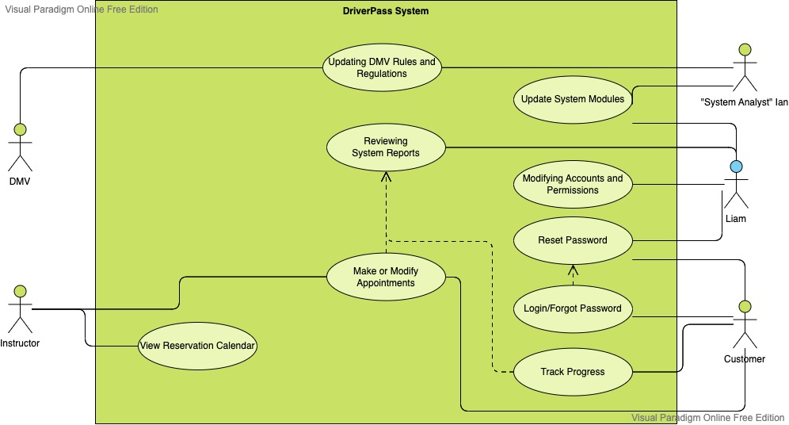

### UML Activity Diagrams

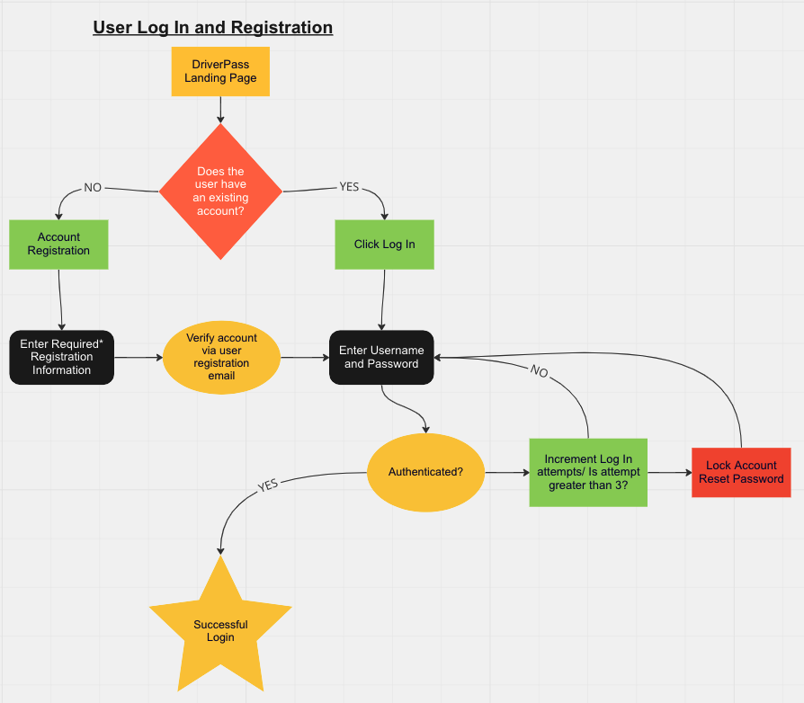

### 

### UML Sequence Diagram

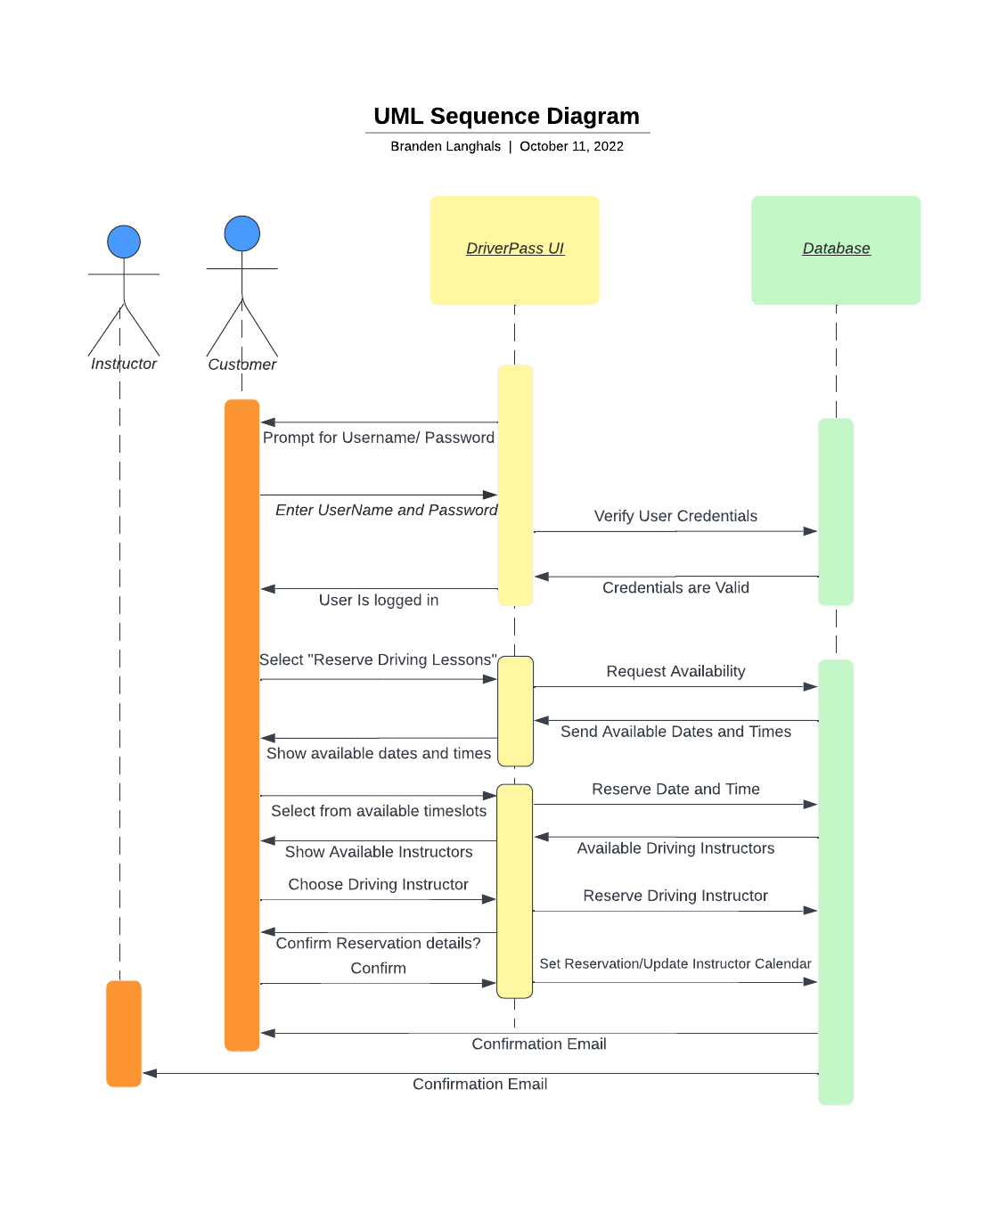

### UML Class Diagram

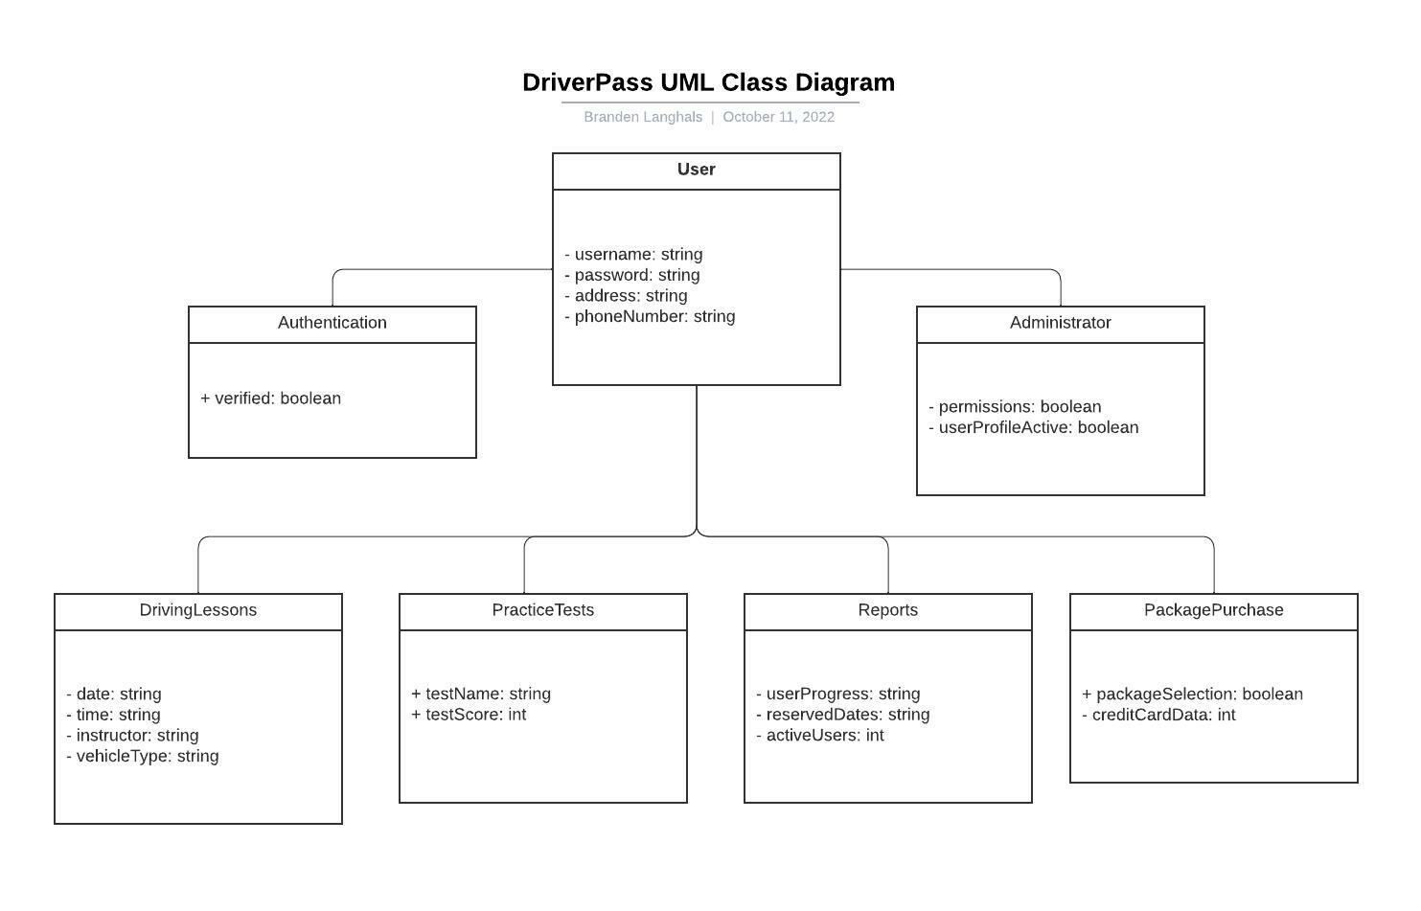

## Technical Requirements

* Internet Connection for all users.
* Computer or Mobile Device for access.
* Cloud servers like Amazon S3 and AWS – access data from anywhere.
* All data will need SSL encryption.
* Payment processing services for the purchase of account upgrades and initial account creation.
* SQL or MongoDB to process data.
* Authentication – Possibly implement Passport.
* REACT front end – easy to make quick changes to the platform when needed.
* Coded in JavaScript.
* Support for Location Services to be enabled to find Instructors available nearby within the United States.